Money Talks: A Web-based Currency Detector Assistance for the Blind

ANTONIO DARREN NOVIANTO SAPUTRA - 2802554634
DOMINICIUS FRANCIS ANG GUNADI - 2802561293
FRANS SEBASTIAN WINATA - 2802489414
GARREN TANAVARO - 2802516182
RICCY RIANDY INTAN - 2802547856

- Problem Statement
There are papers that claim visually impaired Indonesians have difficulty identifying the nominal value of Rupiah banknotes. Although the Rupiah banknote has provided assistance in forms of blind codes, their effectiveness and reliability lessen as the condition of banknotes deteriorates (Fulvian et al., 2025). Moreover, a review paper on computer vision states that computer vision does have a positive impact in supporting visually impaired people (Anthony & Kusnadi, 2021). With this problem in mind, there is an urgency and opportunity to utilize computer vision to assist the visually impaired in identifying the value of Rupiah banknotes. Utilizing computer vision algorithms to extract features like color and texture patterns has been proven effective for robust currency classification (Vishwa et al., 2023). Furthermore, integrating such technologies into applications with real-time audio feedback significantly promotes financial autonomy and inclusivity for the visually impaired (Essakiraja et al., 2024).
- Dataset Source and Description (including licensing/permissions)
This project will utilize the dataset created by mkaspulanwar (https://github.com/mkaspulanwar/rupiah-banknotes-dataset/tree/main?tab=readme-ov-file). The database provides a complete arrangement of Rupiah, the Indonesian currency, in different angles, conditions, and lighting. It also provides a dataset that contains photos of multiple Rupiah together. The dataset itself is under the ‘MIT License’, where users are allowed to use it for commercial, modification, distribution, and private use.

- Initial Plan for Model/Methodology and Baseline
Phase 1 - Preprocessing
- Initial Image Processing and Feature Extraction
  - Load the image and resize it to a uniform target dimension (800 x 400 pixels) while retaining the original color format (BGR)
  - Convert the image from BGR to HSV color space
  - Compute a 3D HSV color histogram (Hue, Saturation, Value) and
  - Apply L2 normalization to the color histogram. This specific normalization method is explicitly used to ensure that the numerical scale of the color features is properly balanced against the ORB texture features before they are fused later on
- Texture Enhancement and Keypoint Detection using ORB
  - Convert the original resized BGR image into grayscale
  - Apply CLAHE (Contrast Limited Adaptive Histogram Equalization) to enhance the local contrast of the grayscale image, making patterns more distinct
  - Apply a Gaussian Blur to reduce noise and smooth the enhanced image
  - Use ORB (Oriented FAST and Rotated BRIEF) on the blurred image to detect and compute up to 2000 keypoints and their corresponding descriptors
- Bag of Visual Words (BoVW) Implementation
  - Aggregate all ORB descriptors extracted from the dataset
  - Use MiniBatch K-Means clustering to group the descriptors and build a visual vocabulary consisting of 800 clusters
  - Quantize the keypoints for each image into a frequency histogram based on the trained K-Means model to represent the final texture features
Phase 2 - Model
- Data Preparation and Splitting
  - Extract both ORB descriptors and HSV color features from the preprocessed dataset
  - Split the extracted features and labels into 80/20 (training/testing) sets, using stratification to keep currency classes balanced across both sets
- Visual Vocabulary Construction
  - Train a MiniBatch K-Means algorithm strictly on the Training set’s ORB descriptors to build the visual vocabulary dictionary and save the K-Means dictionary for inference
  - Generate Raw Bag of Visual Words (BoVW) frequency histograms for both the Training and Testing sets
- Feature Fusion and Custom Weighing
  - Apply TD-IDF (Term Frequency-Inverse Document Frequency) to the raw BoVW histograms. Fitted on only training data, then apply to both sets and save the scaler
  - Texture Weighting to prioritize reading texture patterns and text over color, the TF-IDF weighted BoVW features are explicitly multiplied by a factor of 3.0
  - The heavily weighted BoVW texture features are concatenated with the HSV color features to create the final feature vector
- Support Vector Machine (SVM) Classification
  - Initialize an SVM classifier. Based on the fused feature space, the model utilizes a Linear Kernel, a regularization parameter (C) of 1.0, and balanced class weights
  - Train the SVM classifier on the final Training dataset
  - Predict both the Training and Testing sets to generate the final accuracy scores, evaluate the classification report, and check for model overfitting. Then save the trained SVM model, and clean up any old scaling files from the directory
Phase 3 - Data Augmentation
- Alpha scaling is used to reduce the image brightness by 50% to simulate poor lightning conditions
- Increase the image brightness and contrast to simulate glare or overexposed lightning
- An 11x11 Gaussian blur is applied to simulate a moving camera
- Random normal noise is generated and added to the image to simulate low-quality camera sensors

Phase 4 - Inference and Decision Fusion
- Smart Cropping and Feature Extraction
  - System loads an unseen image and extracts initial ORB keypoints to locate the physical boundaries of the currency
  - A dynamic bounding box is calculated based on the extreme coordinates of the keypoints, and the image is cropped to isolate the money from the background
  - BoVW histograms nd HSV histograms are extracted from this cropped image
  - BoVW TF-IDF features are explicitly multiplied by a factor of 3.0 to force the model to prioritize texture/pattern recognition over color
- Primary Prediction
  - The fused features are passed into a trained SVM
  - The SVM outputs a base prediction label and calculates the prediction confidence probabilities
- Secondary Prediction
  - The cropped image is enlarged to make the text readable
  - The image is sliced into 5 distinct Regions of Interest (ROI): Full, Left, Right, Center, Top-Left
  - Each ROI undergoes multiple preprocessing steps and is passed through Tesseract OCR using different Page Segmentation Modes
  - The recognized text is cleaned using Regular Expressions to isolate digits, a method that has demonstrated high accuracy in finding nominal patterns specifically in Rupiah banknotes via OCR (Bahar et al., 2023).
  - The Levenshtein distance algorithm is applied to match these digits against known IDR denominations, generating an OCR “voting score”
- Confidence-Based Rule Fusion
  - If both SVM and OCR predict the same denomination, the overall confidence is boosted
  - If SVM is weak or ambiguous, and OCR has a high voting ratio, the OCR prediction overrides the SVM
  - If OCR can’t find any readable text, or if the OCR vote is too weak to challenge a highly confident SVM prediction, the system defaults to the SVM’s original guess

The following images illustrate how the proposed model identifies currency denominations and provides corresponding text-based feedback to the user.
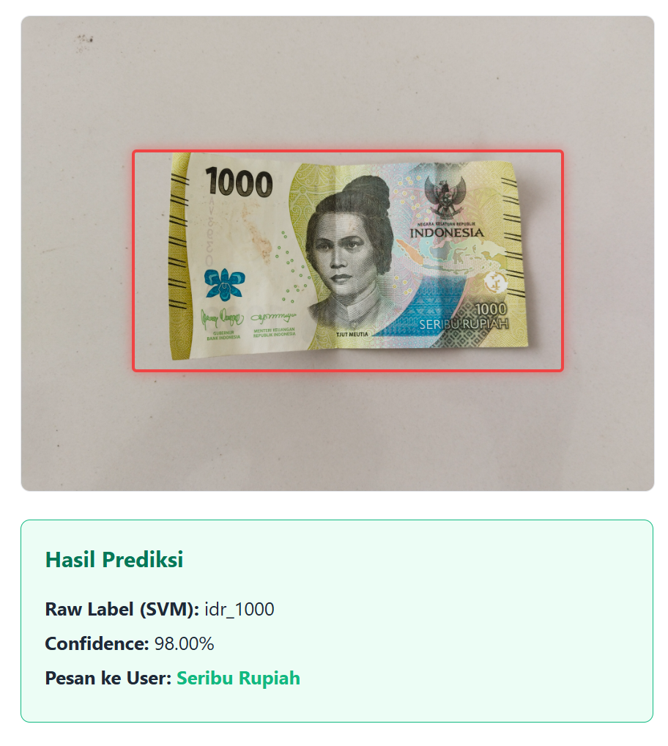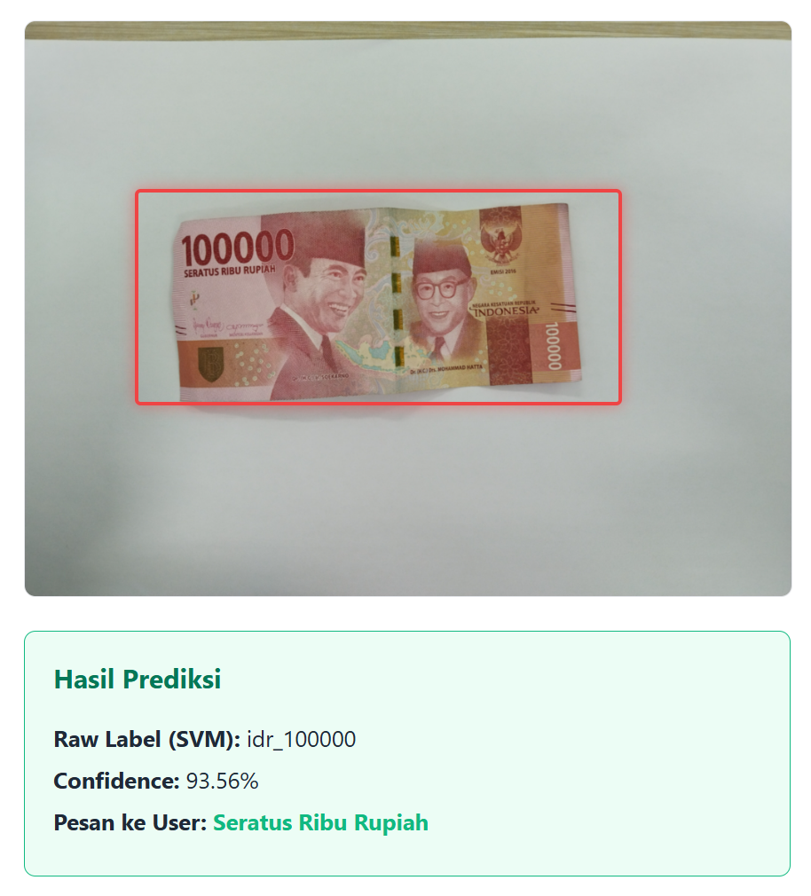

Phase 5 - Deployment
- Backend Infrastructure (Flask API)
The Flask server, hosting the trained SVM model and the OCR engine
- Model Serving: The trained SVM model, the MiniBatch K-Means visual vocabulary, and the TF-IDF scalers are loaded into memory upon server startup using joblib or pickle to ensure near-instant inference.
- API Endpoints:
  - POST /predict: Receives a Base64 encoded image or a multipart form-data frame from the frontend.
  - The backend runs the Phase 4 logic (Smart Cropping → SVM → Tesseract OCR → Decision Fusion).
  - Response Payload: Returns a JSON object containing the denomination, confidence_score, and a message string (e.g., { "result": "50000", "confidence": 0.92, "speech": "Fifty Thousand Rupiah" })
- Frontend Capture (MediaDevices API)
- Camera Stream: Using navigator.mediaDevices.getUserMedia({ video: { facingMode: "environment" } }) to access the smartphone's rear camera.
- Frame Capture Logic: Instead of a "Take Photo" button, the system implements an automated heartbeat. Every 1–2 seconds, a script captures a frame from the video stream, draws it onto a hidden HTML5 <canvas>, and sends the data to the Flask /predict endpoint.
- Text to speech (Web Speech API)
- Speech Synthesis: The window.speechSynthesis interface is used to convert the JSON response from the backend into audible speech.
- Status Feedback: The API provides verbal cues for system status, such as:
  - "Camera starting..."
  - "Detecting... please hold steady."
  - "Network error, trying again.
- UX Design for the Visually Impaired
Feature | Implementation | Purpose
Full-Screen Trigger | A single, large tap-to-start area covering the entire screen. | Eliminates the need to find a specific "Start" button.
Vibration (Haptics) | navigator.vibrate(200) | Provides a physical pulse when a bill is successfully identified, confirming the action to the user.
ARIA Live Regions | aria-live="polite" or "assertive" | Ensures that screen readers (like TalkBack or VoiceOver) prioritize the denomination announcements.
Audio Pinging | Low-volume "radar" beeps. | Informs the user that the app is still active and scanning.

- Deployment Workflow Summary
- Initialization : The user opens the web URL, then the browser requests camera permissions via MediaDevices API.
- Continuous Scanning: The browser captures a frame and sends it to Flask.
- Processing: Flask executes the Preprocessing, SVM prediction, and OCR validation.
- Audio Output: Flask returns the value; the Web Speech API announces: "Sepuluh Ribu Rupiah".
- Loop: The system waits for a short cooldown and repeats the process.

- Planned Evaluation Metrics and Success Criteria
The system will be evaluated using Accuracy, Precision, Recall, F1-score, and Confusion Matrix to measure classification performance on the test set. The proposed model will also be compared with a KNN-based baseline to determine whether the selected method provides better recognition performance. In addition, processing time per image and end-to-end response time will be measured to evaluate practical usability in a web-based application. Voice output correctness and performance under different lighting and banknote conditions will also be observed.
The project will be considered successful if the model achieves at least 85% accuracy, produces correct voice output, and responds fast enough for practical use. The system is also expected to maintain acceptable performance under varied real-world image conditions.
- References
Fulvian, C. S. A., Ramadhani, K. N., & Sthevanie, F. (2025). Nominal classification of Rupiah banknotes images using Vision Transformer. 2025 IEEE International Conference on Artificial Intelligence for Learning and Optimization (ICoAILO), 126–132. https://doi.org/10.1109/icoailo66760.2025.11155989
Anthony, E. J., & Kusnadi, R. A. (2021). Computer Vision for Supporting Visually Impaired People: A Systematic Review. Engineering Mathematics and Computer Science (EMACS) Journal, 3(2), 65–71. https://doi.org/10.21512/emacsjournal.v3i2.6923
Bahar, Raban, R. D. Y., & Arnie, R. (2023). Model Pendeteksi Nominal Uang Kertas Rupiah Menggunakan Teknologi Optical Character Recognition. Jurnal TICOM: Technology of Information and Communication, 12(1), 8-13. https://doi.org/10.70309/ticom.v12i1.101
Essakiraja, S., Vishwanathan, M. K., Anton Gino, J. A., & Subbulakshmi, T. C. (2024). An Application for Currency Detection for Visually Impaired. International Journal of Novel Research and Development (IJNRD), 9(4), 1324-1331. https://www.ijnrd.org/papers/IJNRD2404843.pdf
Vishwa, R., Stockwell, H. C., Srinivas, V., Mohandoss, R., Rameshbabu, V., & Anand, M. (2023). Currency Detection for Blind People Using Image-Processing. Tuijin Jishu/Journal of Propulsion Technology, 44(5), 5129-5134. https://www.propulsiontechjournal.com/index.php/journal/article/view/5148
J. M. R. Apoloni, S. D. G. Escueta, and J. T. Sese, "Philippine Currency Counterfeit Detector using Image Processing," 2022 IEEE 18th International Colloquium on Signal Processing & Applications (CSPA), 2022, pp. 436-441, doi: 10.1109/CSPA55076.2022.9781980.

